**Dose-Response study**

In this course you will learn how to perform a dose response analysis. Therefore you can find images from a 48h dose-response experiment in the Appendix (I/II. Dose-response pictures). You can find in the appendix also a table describing the heartbeat and the movements of the exposures in the dose response pictures. You need the table and the pictures to perform a dose response analysis. To get an idea how malformations can look like you have in the appendix pictures of commonly induced malformations and their names(II. Developmental malformations ). Parts of the embryo that are not visible in the picture can be expected as normal.

To do a dose-response analysis use the checklist underneath to score the effects. Describe what you see in Table 1. Count the number of normal, malformed (non lethal effects) and dead (lethal effects) embryos and write the results in Table 2.

**Checklist:**

Lethal effects: Non lethal effects: Others:

C = Coagulated embryos M =Malformations NA = Empty well

NM = No Movement E =Edema - = No effects

NH = No Heartbeat

Tab.1: Describe what you see

|  |  |  |  |  |  |  |  |  |  |  |  |  |
| --- | --- | --- | --- | --- | --- | --- | --- | --- | --- | --- | --- | --- |
| **Concentration** | **1** | **2** | **3** | **4** | **5** | **6** | **7** | **8** | **9** | **10** | **11** | **12** |
| **1** |  |  |  |  |  |  |  |  |  |  |  |  |
| **2** |  |  |  |  |  |  |  |  |  |  |  |  |
| **3** |  |  |  |  |  |  |  |  |  |  |  |  |
| **4** |  |  |  |  |  |  |  |  |  |  |  |  |
| **5** |  |  |  |  |  |  |  |  |  |  |  |  |
| **Negative control** |  |  |  |  |  |  |  |  |  |  |  |  |
| **Positive control** |  |  |  |  |  |  |  |  |  |  |  |  |

Tab.2: Results of the experiment

|  |  |  |  |  |  |
| --- | --- | --- | --- | --- | --- |
|  | Number of embryos with lethal or non lethal effects | | |  |  |
| Concentration | Normal | Lethal effects | Non lethal effects | % Mortality  (only lethal) | % Effected (non lethal + lethal) |
| 1 |  |  |  |  |  |
| 2 |  |  |  |  |  |
| 3 |  |  |  |  |  |
| 4 |  |  |  |  |  |
| 5 |  |  |  |  |  |
| Positive Control |  |  |  |  |  |
| Negative Control |  |  |  |  |  |

Draw the Does-response curve for lethal and effected embryos (XY-plot; X=concentration, Y=percentage of effected or dead embryos like shown in Figure 3).

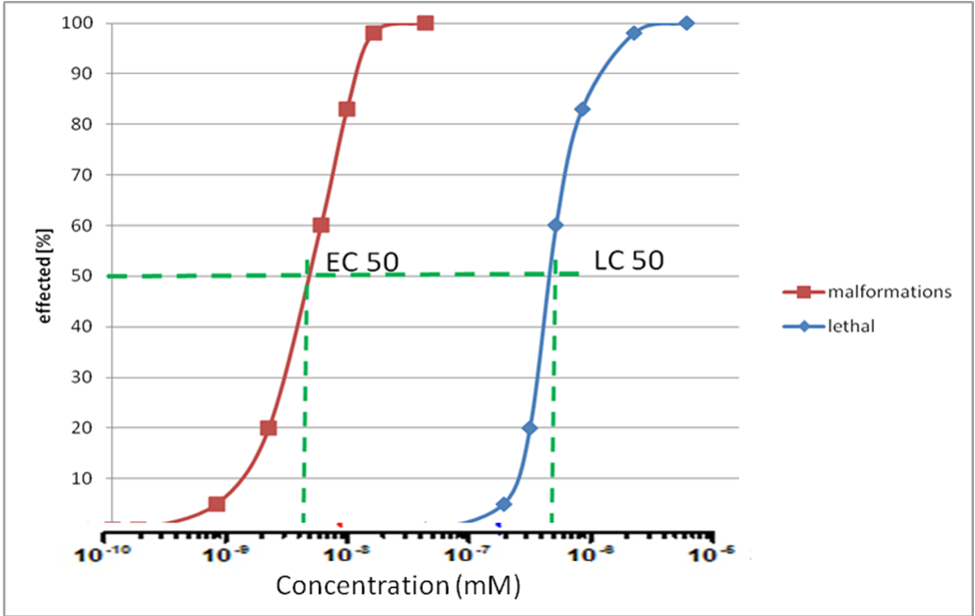

Fig.:1 Dose-Response curve for lethal and non-lethal effects

Your Dose-response curve:

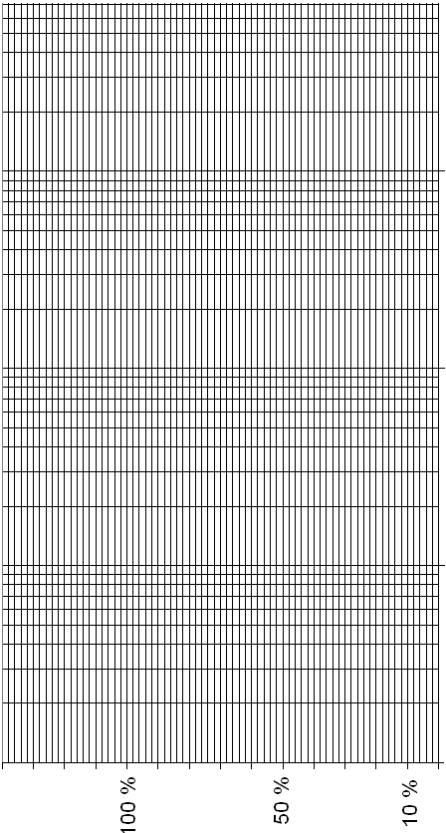

Determine the LC50, EC50, NOEC and TI.

* LC50: Concentration where 50% of the treated embryos are dead
* EC50: Concentration where 50% of the treated embryos are affected (malformed and dead)
* NOEC: Highest concentration with no effects compared to the control group
* LOEC: Lowest concentration with effects compared to the control group
* Teratogenic Index (TI) = LC50 / EC50

NOEC: _________________

LOEC: __________________

LC50: __________________

EC50: __________________

TI: _____________________

## I. Dose-response pictures

# Negative control

1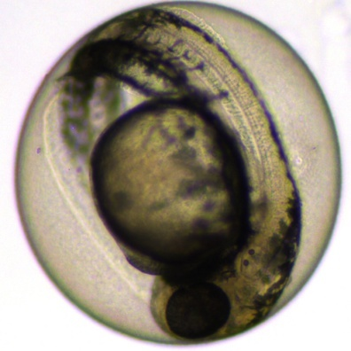2 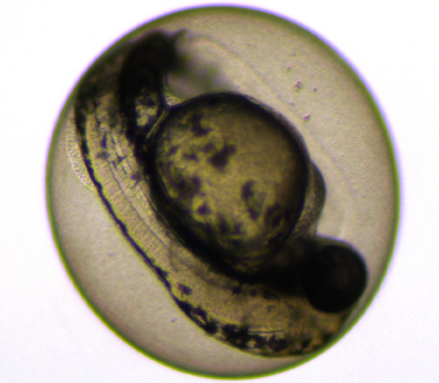3 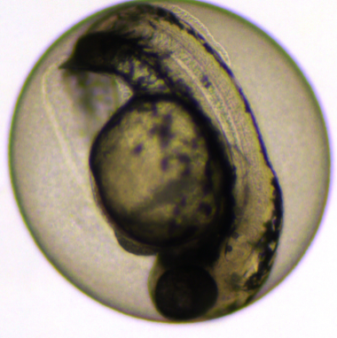

4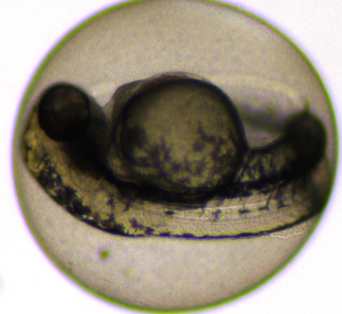5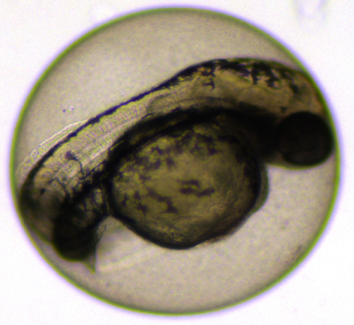6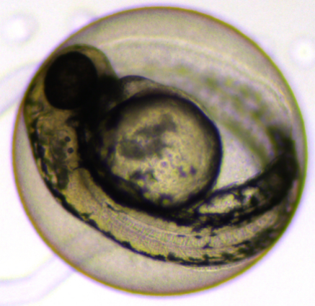

7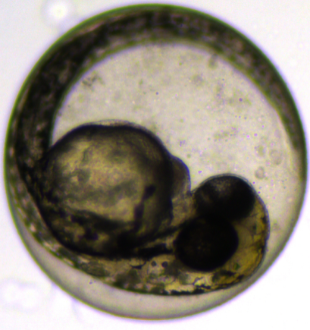8 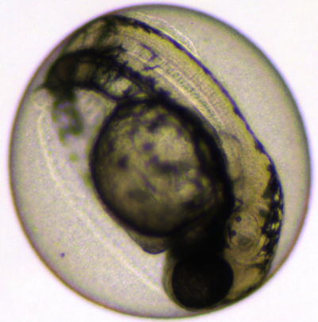 9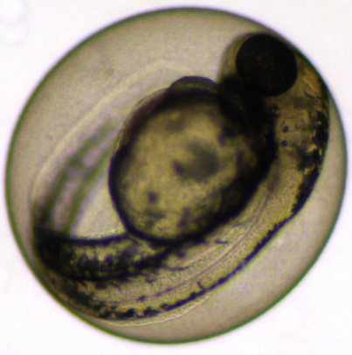

10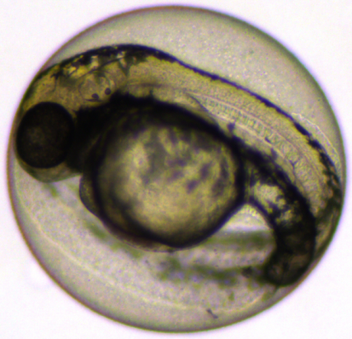 11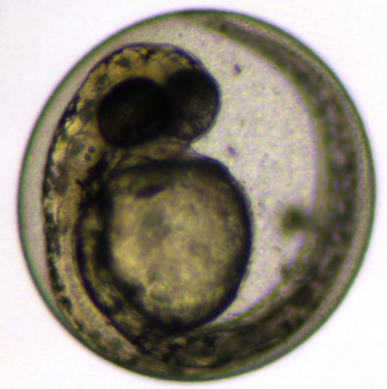 12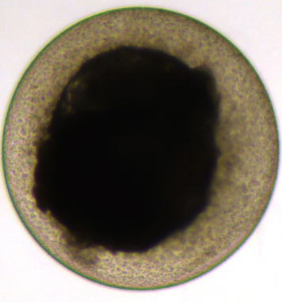

# 

# Positive control

1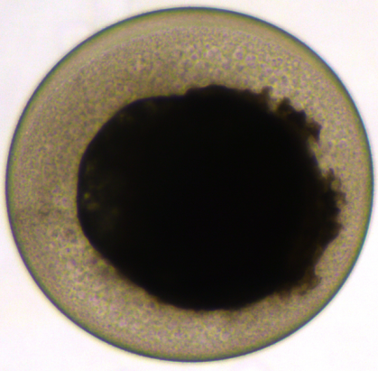2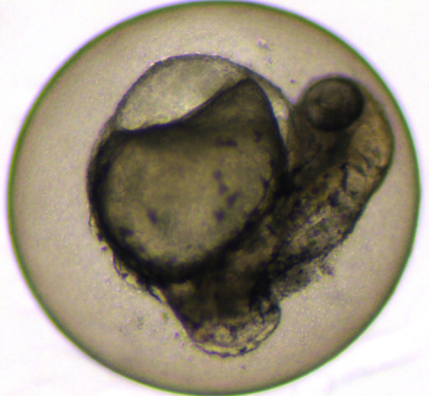3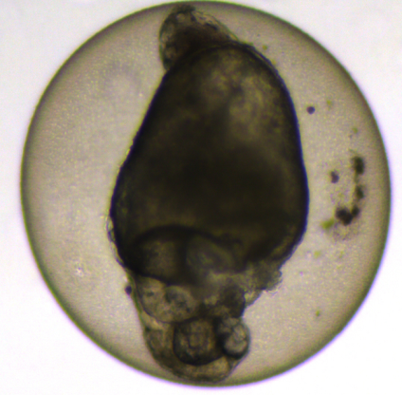

4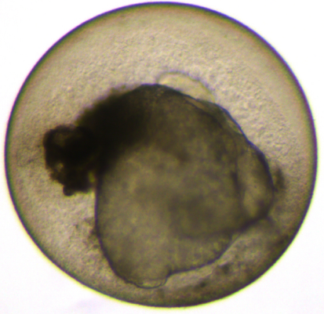5 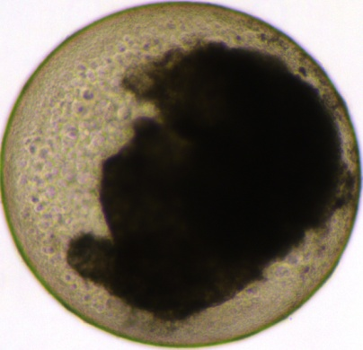6 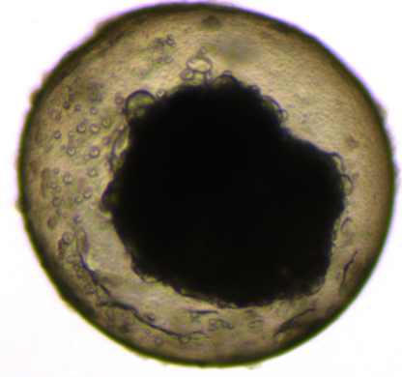

7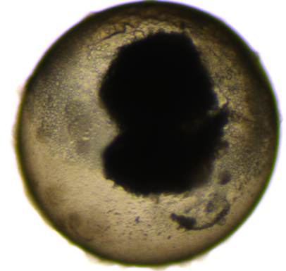8 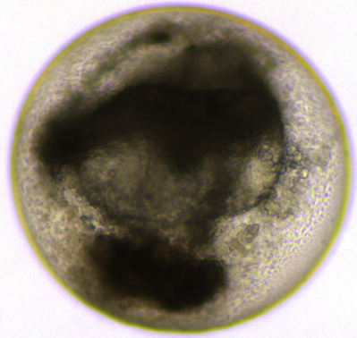9 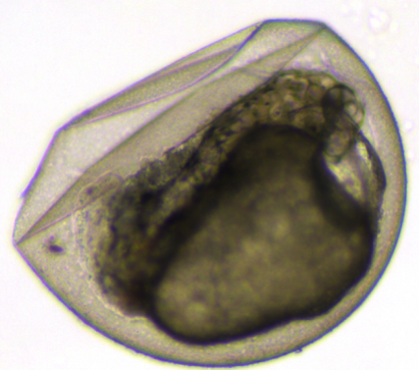

10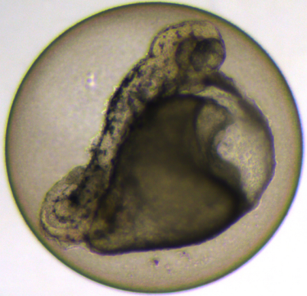11 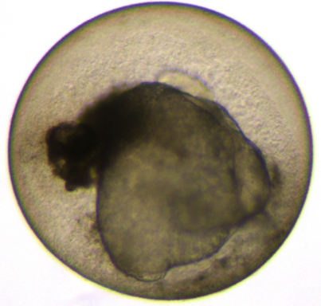 12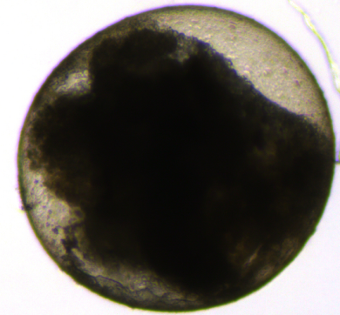

# 0.06 mM Chlorpyrifos

1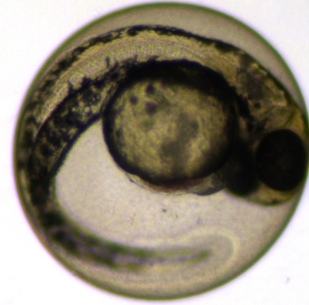 2 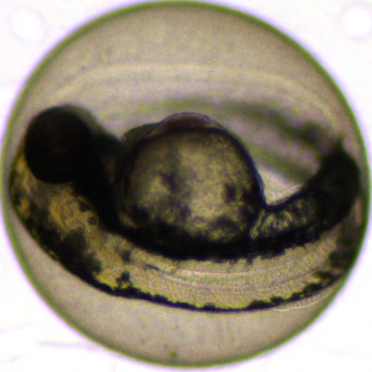 3 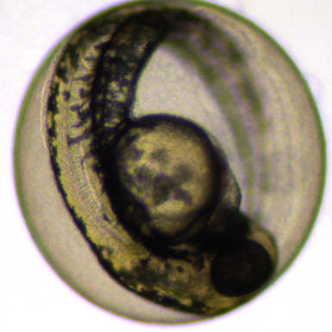

4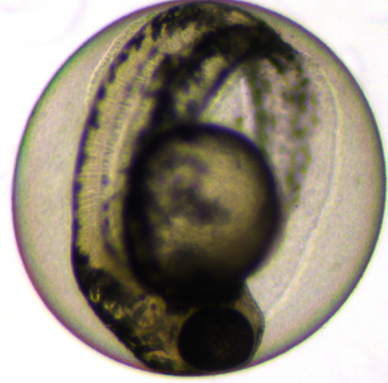 5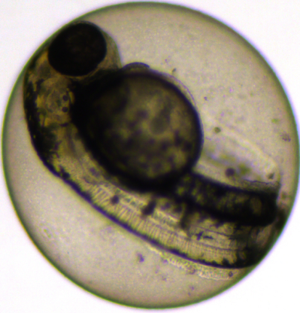 6 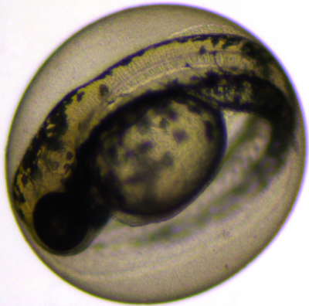

7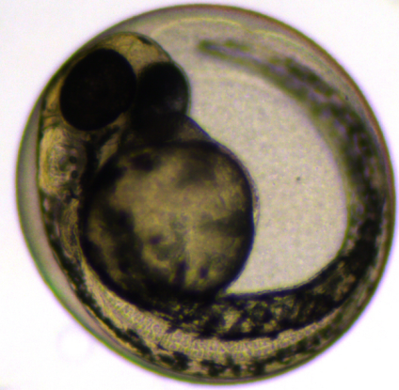 8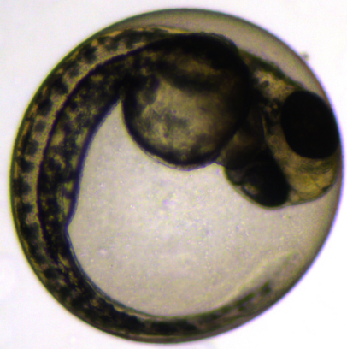 9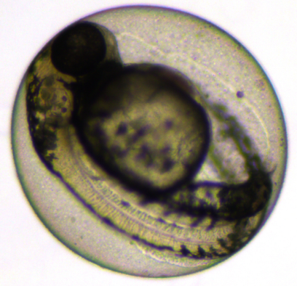

10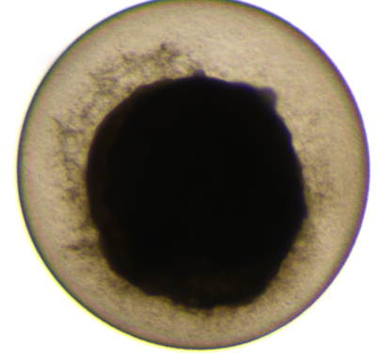11 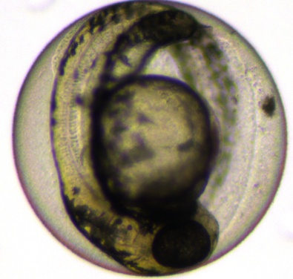 12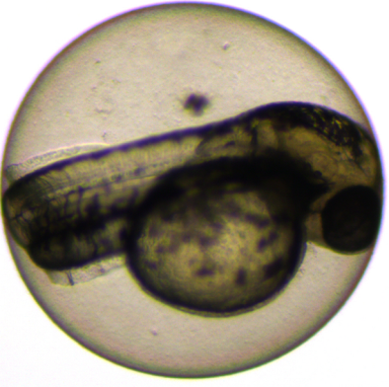

# 

# 0.15 mM Chlorpyrifos

1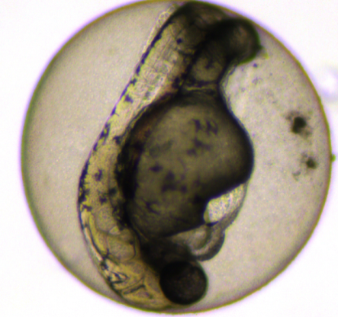2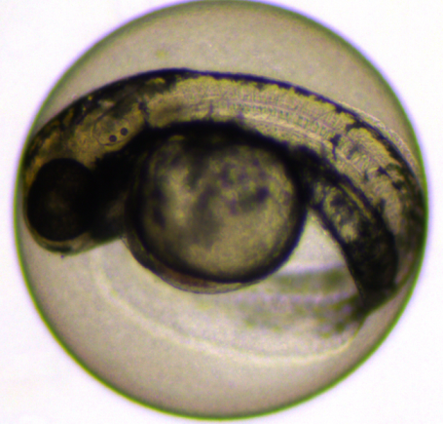3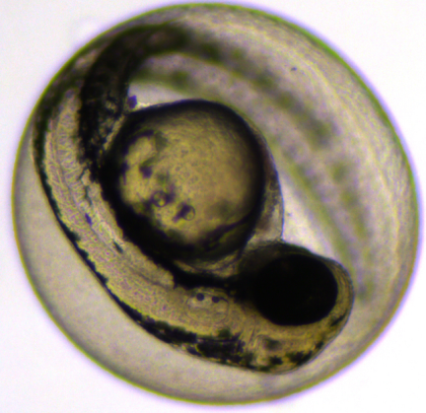

4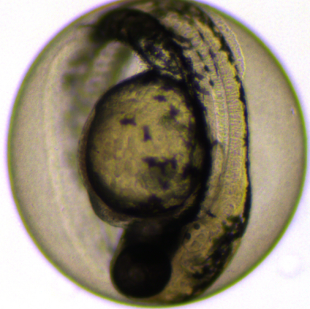5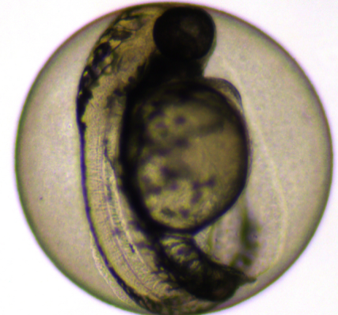6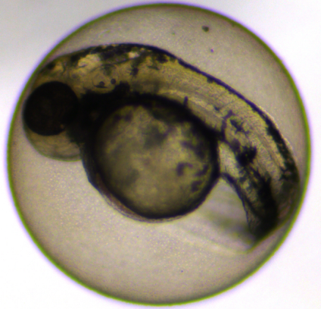

7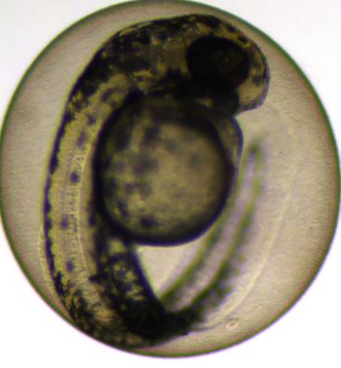 8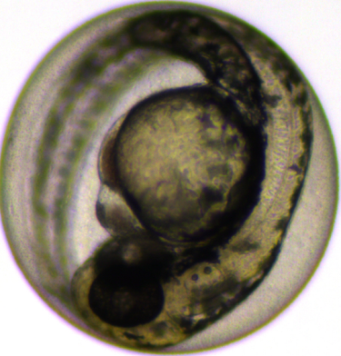9 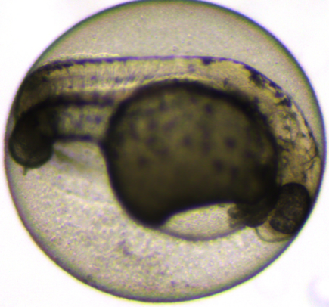

10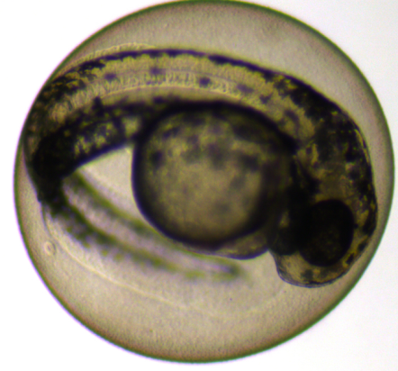11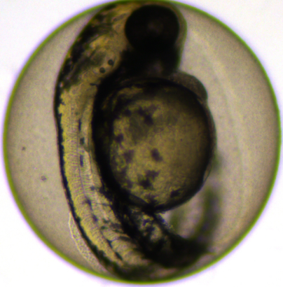12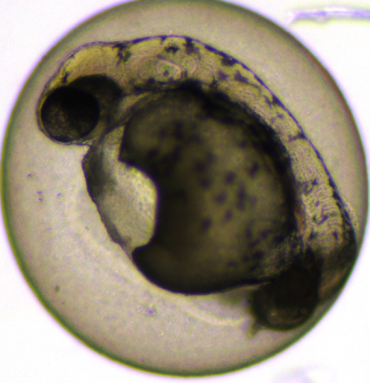

# 1 mM Chlorpyrifos

1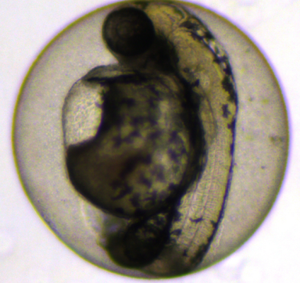2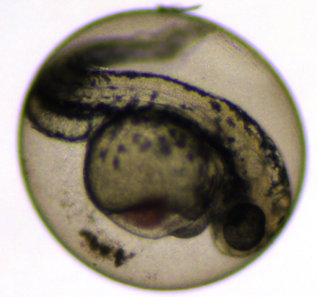3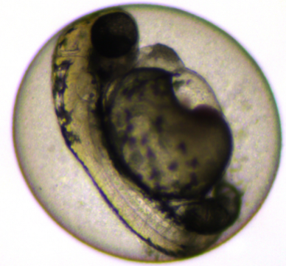

4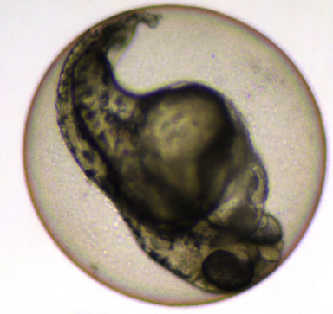5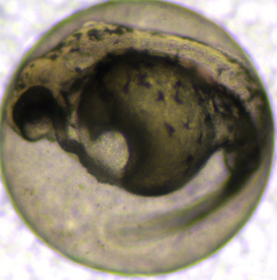6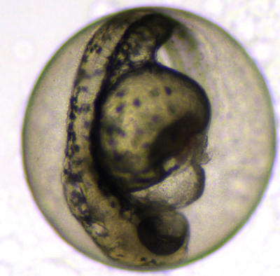

7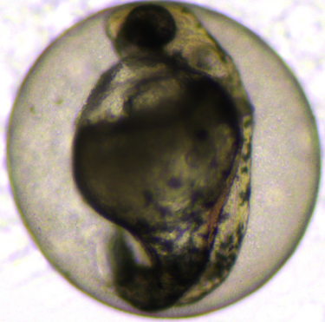8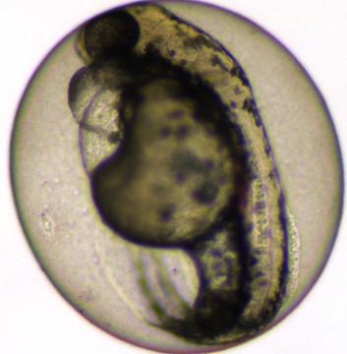9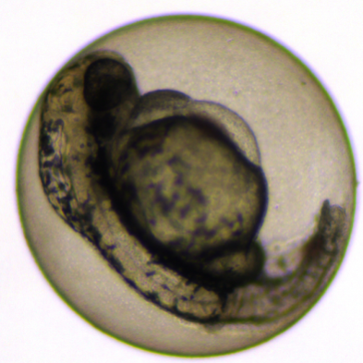

10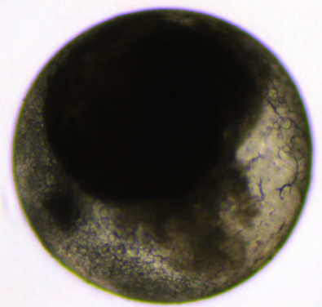11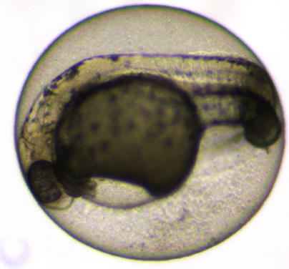12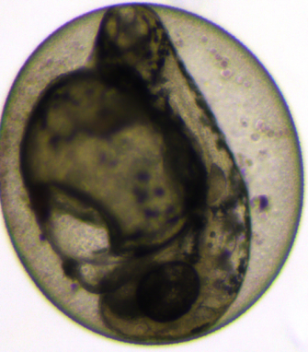

# 

# 5 mM Chlorpyrifos

1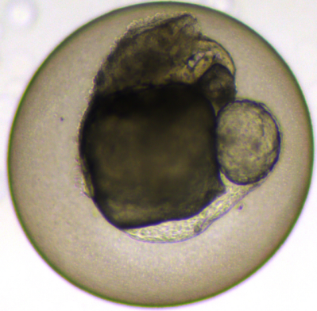2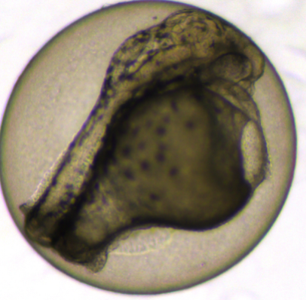3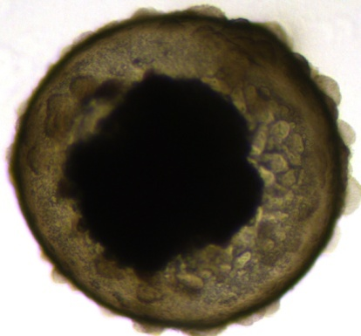

4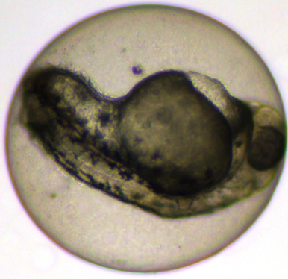5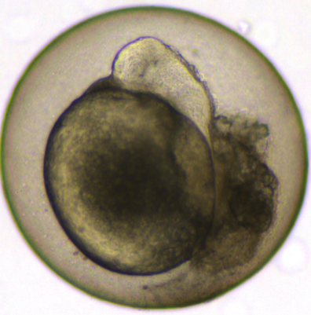6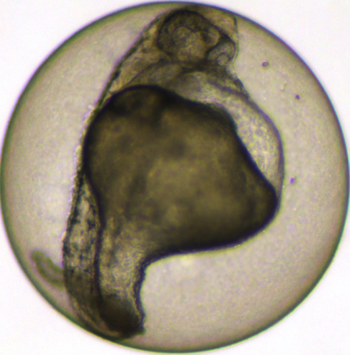

7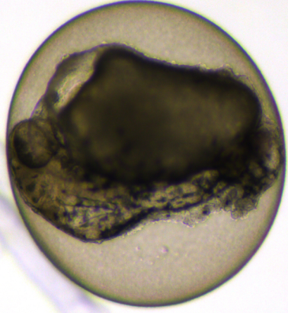8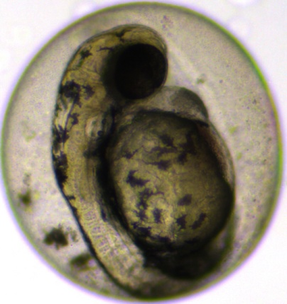9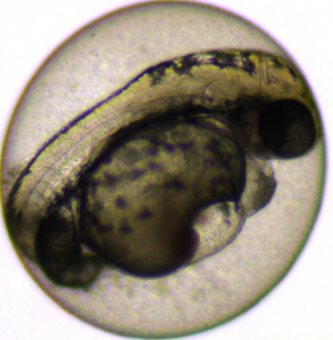

10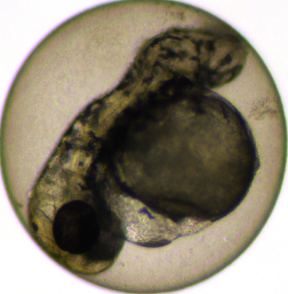11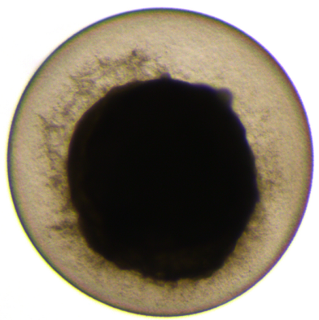12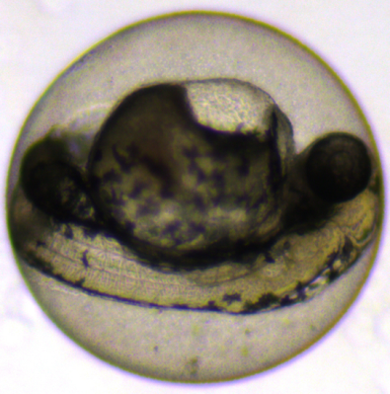

# 

# 11 mM Chlorpyrifos

1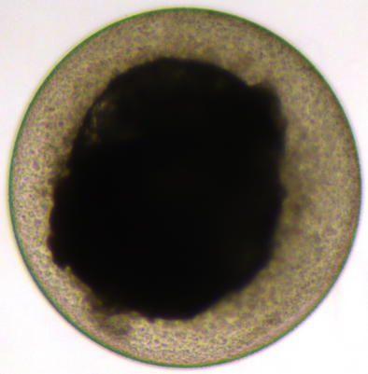2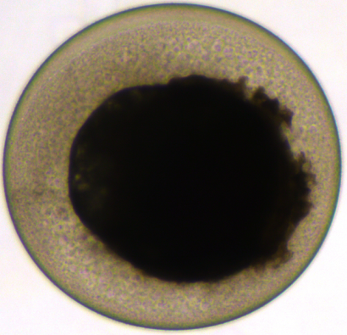3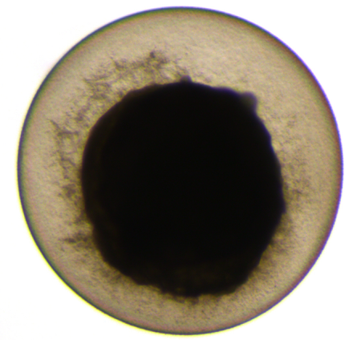

4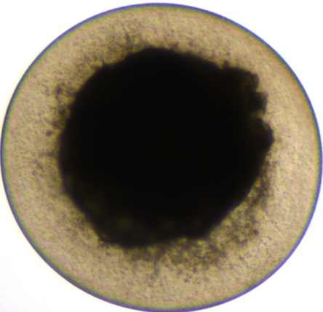5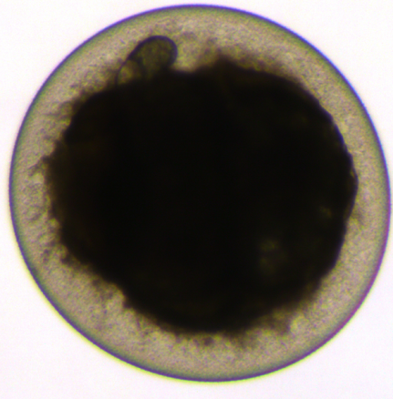6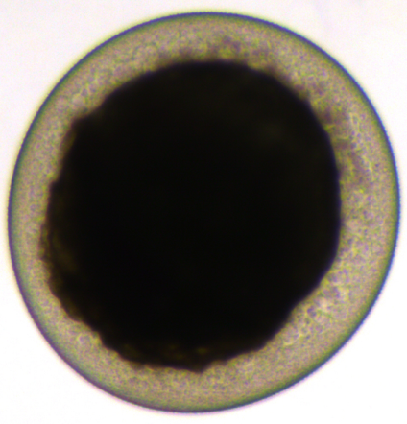

7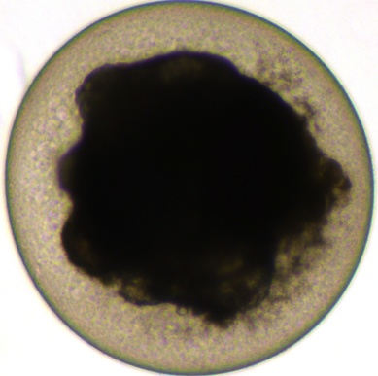8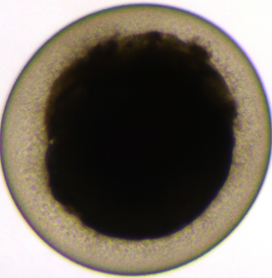9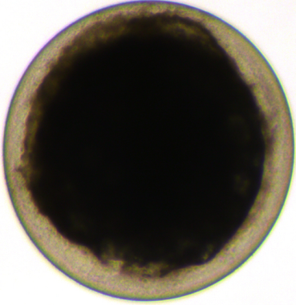

10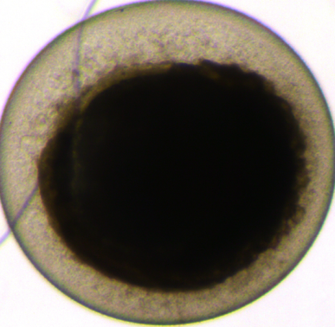11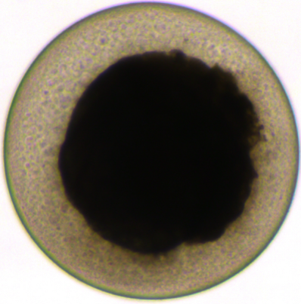12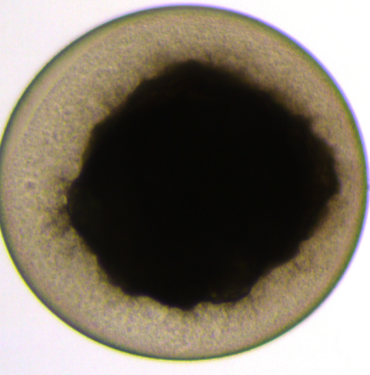

## II. Dose-response heart beat and movement

Heart beat

|  |  |  |  |  |  |  |  |  |  |  |  |  |
| --- | --- | --- | --- | --- | --- | --- | --- | --- | --- | --- | --- | --- |
|  | 1 | 2 | 3 | 4 | 5 | 6 | 7 | 8 | 9 | 10 | 11 | 12 |
| Negative control | ok | ok | ok | ok | ok | ok | ok | ok | ok | ok | ok | no |
| 0.06 mM | ok | ok | ok | ok | ok | ok | ok | ok | ok | no | ok | ok |
| 0.15 mM | ok | ok | ok | ok | ok | ok | ok | ok | ok | ok | ok | ok |
| 1 mM | ok | ok | ok | ok | ok | ok | ok | ok | ok | no | ok | ok |
| 5 mM | no | slower | no | ok | no | slower | no | ok | ok | slower | no | ok |
| 11 mM | no | no | no | no | no | no | no | no | no | no | no | no |
| Positive control | no | no | no | no | no | no | no | no | no | no | no | no |

Movements

|  |  |  |  |  |  |  |  |  |  |  |  |  |
| --- | --- | --- | --- | --- | --- | --- | --- | --- | --- | --- | --- | --- |
|  | 1 | 2 | 3 | 4 | 5 | 6 | 7 | 8 | 9 | 10 | 11 | 12 |
| Negative control | ok | ok | ok | ok | ok | ok | ok | ok | ok | ok | ok | no |
| 0.06 mM | ok | ok | ok | ok | ok | ok | ok | ok | ok | no | ok | ok |
| 0.15 mM | ok | ok | ok | ok | ok | ok | ok | ok | ok | ok | ok | ok |
| 1 mM | ok | less | ok | less | less | ok | less | less | less | no | ok | ok |
| 5 mM | no | less | no | less | no | less | no | less | less | less | no | less |
| 11 mM | no | no | no | no | no | no | no | no | no | no | no | no |
| Positive control | no | no | no | no | no | no | no | no | no | no | no | no |